Best one {

<https://youtu.be/p_9t8uhXQdk>

<https://youtu.be/1t1_a1BZ04o>

}

To refer {  
  
<https://www.youtube.com/watch?v=8wysIxzqgPI>

}

Jobs now:

Referred {  
  
<https://youtu.be/Kte-t1pQQ3I>

}

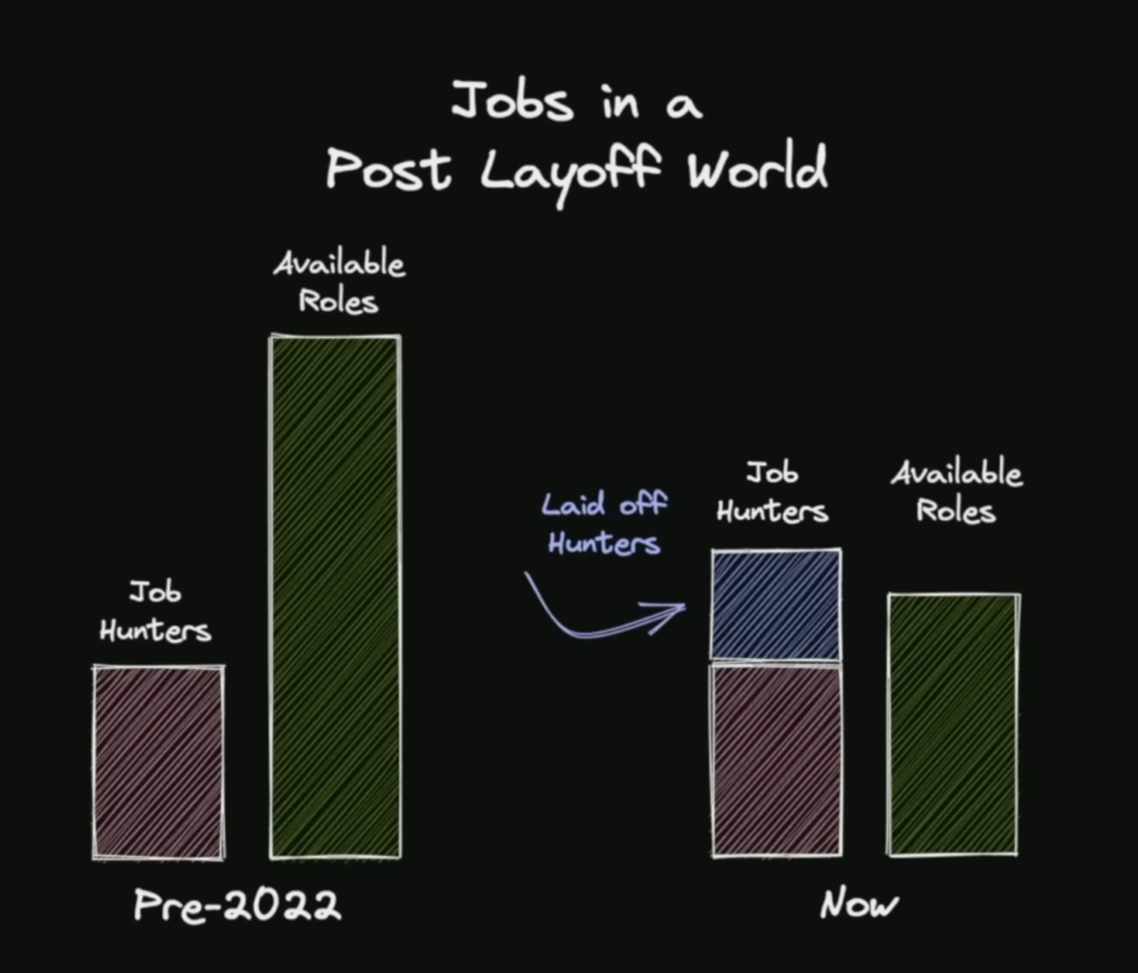

Job hunters ( skilled ones ) are less, but job availability is high , so even unskilled people too got job in early 2022.. but now, companies laid off people since no roles and which affect both recuirting side and hunting side.

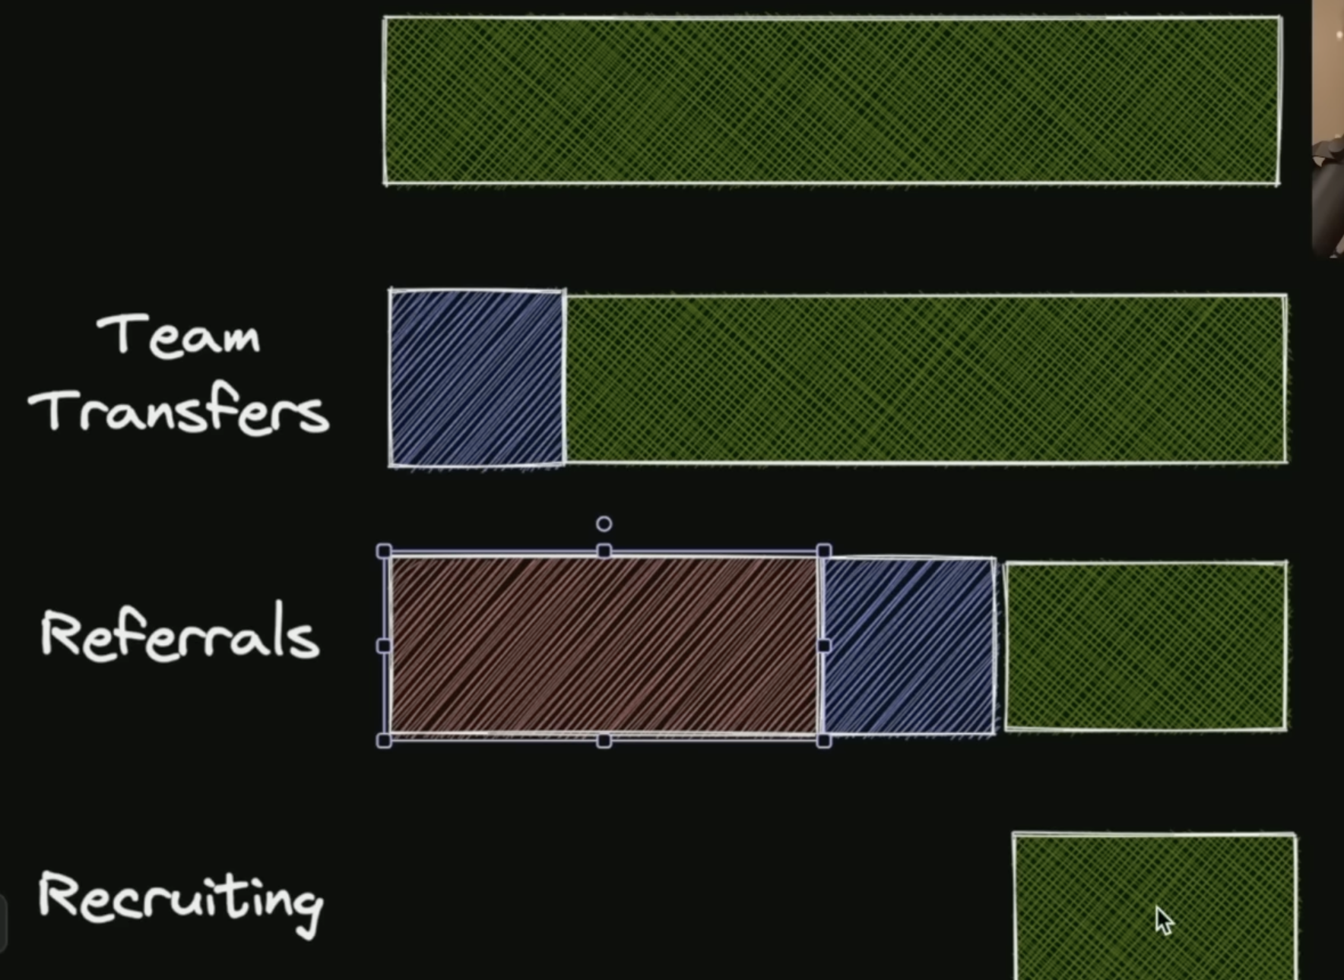

Out of open new positions, 25% were team transfers ( best choice instead of lay off ), and 45% were referrals taking jobs, and only 30% were recurting directly …

Old job vs new job models:

Old model:  
  
People suggesting old models since they were popular before which have high ratio of recuirting..  
  
  
People consider recuirting people who have   
* best code applications  
* best university degree grades  
* leetcode skills  
* grid and resilience

Grit is about sustained, consistent effort toward a goal even when we struggle, falter, or temporarily fail. Resilience is our ability to bounce back after we have struggled, faltered, or failed

New model:  
* OSS – open source

*Communities – tech communities communication and intractions   
*Impact – person indirectly impacted your betterment ( code sharing etc )

Prettier  
  
reffered {  
  
<https://youtu.be/Cd-gBxzcsdA>

}

For more {  
<https://www.youtube.com/watch?v=sSJBeWPIipQ>

<https://prettier.io/docs/en/integrating-with-linters.html>

<https://prettier.io/docs/en/comparison.html>

<https://www.libhunt.com/compare-dprint-vs-prettier>

}  
  
formatter vs linter  
  
Formatter – run code fix formatting in code – things are in right shape

Linter – confirms code following specific discrete rules which involves some complexity in things – things are analysed and confirmed as expected rules set

Linting should be outside of formatter, First do the formatting of code and then do linting which is right way…

In eslint config prettier which is plug-in turns off all ESlint that conflicts with prettier ( prettier defaults are mostly enough , we don’t need config mostly )

Dprint – new fast alternative for prettier

Prettier is a JavaScript-based code formatter with support for many languages. dprint is a Rust-based code formatting platform that formats code with formatting plugins including a Prettier plugin

| **dprint** | **Prettier** |
| --- | --- |
| Purpose | Code formatter and linter | Code formatter |
| Language | Supports multiple languages | Primarily focused on JavaScript |
| Configurability | Highly configurable | Less configuration options |
| Formatting Options | Provides a wide range of formatting options | Offers opinionated formatting rules |
| Extensibility | Plugin-based architecture | Limited extensibility |
| Formatting Accuracy | Designed for consistent formatting | Emphasizes code style uniformity |
| Community Support | Growing community and active development | Large and established community |
| Development Team | Developed and maintained by the dprint organization | Developed and maintained by the Prettier team |
| Integration | Integrates with various editors and CI/CD pipelines | Integrates with popular editors and build tools |
| Compatibility | Supports a wide range of code editors | Supports popular code editors |